# CrashCourse

## What is CrashCourse?

**# Source**: **Chatgpt (GPT-5-Standard) at [8/27/2025]**

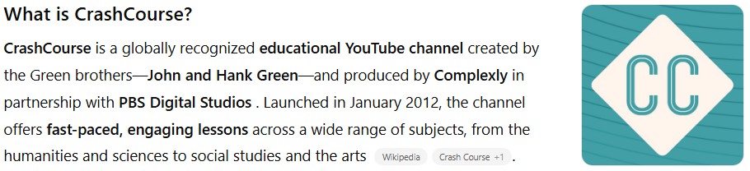

**CrashCourse** is a globally recognized **educational YouTube channel** created by the Green brothers—**John and Hank Green**—and produced by **Complexly** in partnership with **PBS Digital Studios** ([Wikipedia](https://en.wikipedia.org/wiki/Crash_Course_%28web_series%29?utm_source=chatgpt.com)). Launched in January 2012, the channel offers **fast-paced, engaging lessons** across a wide range of subjects, from the humanities and sciences to social studies and the arts ([Wikipedia](https://en.wikipedia.org/wiki/Crash_Course_%28web_series%29?utm_source=chatgpt.com), [Crash Course](https://thecrashcourse.com/?utm_source=chatgpt.com)).

With more than **44 distinct course series**, CrashCourse includes topics like **World History, Chemistry, Computer Science, Art History, Philosophy, and many others** ([Wikipedia](https://en.wikipedia.org/wiki/Crash_Course_%28web_series%29?utm_source=chatgpt.com), [Crash Course](https://thecrashcourse.com/?utm_source=chatgpt.com)). The series blends animated visuals, energetic narration, and structured content to make learning enjoyable and accessible.

## Key Highlights

**# Source**: **Chatgpt (GPT-5-Standard) at [8/27/2025]**

* **Platform:** YouTube
* **Language:** English (predominantly; also has an Arabic edition)
* **Format:** Bite-sized, visually rich educational video courses
* **Creators:** John and Hank Green (with expanded hosting by others)
* **Produced by:** Complexly and PBS Digital Studios
* **Focus:** High school- and college-level topics in humanities, sciences, and more
* **Subscribers:** ~16.6 million (as of August 2025)
* **Total Views:** ~2.1 billion

## Summary Table

**# Source**: **Chatgpt (GPT-5-Standard) at [8/27/2025]**

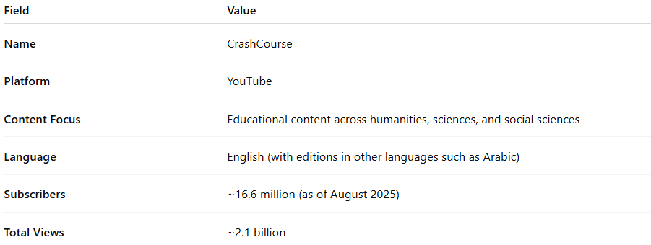

| **Field** | **Value** |
| --- | --- |
| **Name** | CrashCourse |
| **Platform** | YouTube |
| **Content Focus** | Educational content across humanities, sciences, and social sciences |
| **Language** | English (with editions in other languages such as Arabic) |
| **Subscribers** | ~16.6 million (as of August 2025) |
| **Total Views** | ~2.1 billion |